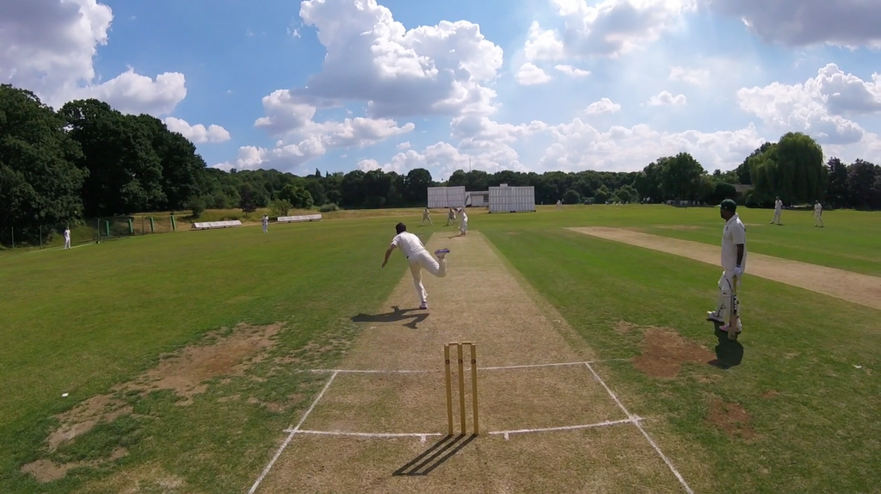

**March 2019  
Update**

**Brown Building renews their sponsorship deal for 2019!**

|  |  |
| --- | --- |
| cid:image010.png@01D2C430.2065EA30  cid:image005.jpg@01D3C134.AA637020 | The Club is thrilled to report that [Brown Building](https://www.brownbuilding.co.uk/) has extended their sponsorship deal into 2019. Brown Building will be main sponsor of the Junior and Women’s section and secondary sponsor of the Men’s section.  Many of you will know the owner - David Brown - as our 2017 Club Person of the Year, a member who donated huge amounts of time and skill at CricketForce 2017 and the current Sunday 2s captain. As you can imagine, it’s not easy getting sponsors in the current climate so please do think of Brown Building for your next building project – I can happily recommend from a quality of work perspective and just as a top bloke!  Senior kit, featuring the logo’s of both Brown Building and Simon Wright Jewellery, can now be purchased from AllRounder by [clicking here](https://www.allroundercricket.com/teamwear/cricket-teamwear/s/streatham-and-marlborough-cc). David has generously covered the additional printing cost of his logo – this discount (£3.49) will be applied automatically to “MY BASKET” when you choose an item.  *PS We are still looking for sponsors to help with the cost of replacing our pitch covers so if anyone else has any leads, please do let me know.* |

**CricketForce 2019 – 6 April & 7 April**

|  |  |
| --- | --- |
| cid:image006.jpg@01D4D428.4EF534A0 | In 2017, the Club kicked off [CricketForce](https://www.ecb.co.uk/be-involved/club-support/club-events/natwest-cricketforce) nationally – for info, see [The Guardian](https://www.theguardian.com/cricket-has-no-boundaries/2017/jul/19/save-our-stumps-how-cricketforce-came-to-the-rescue-for-uk-clubs) and this [ECB video](https://www.youtube.com/watch?v=vQgPTzADHf4) - and made some substantial improvements to the facilities.  Planning for the event is taking place and we would love to hear if anyone is interested in getting involved – think the front could do with a tidy up? Bored of looking for balls in undergrowth? Now’s your chance to have your say and direct what we do.  This event only works if you kindly donate some of your time to do the various tasks and make the club better for everyone – please do make an effort to attend over the weekend. |

In other news:

* The latest Club Development Plan has been agreed, please see the attached document to see our recent successes as well as plans for 2019 and beyond.
* Pavilion Update: we are currently going through various design iterations with our potential nursery partners and architects. Timeline is tight but we’re still pushing for a build starting at the end of the season.
* Need kit? As a club, we have an association with [Woodstock Cricket](https://www.woodstockcricket.co.uk/) (who I can personally recommend) and have also recently secured a deal with newcomers to the market, [Garrard & Flack](https://garrardandflack.com/) (courtesy of Raj Patel’s recommendation). Both offer significant discounts to list price - please contact me for more details.
* Drink local! We’re very happy to be stocking [Gipsy Hill Brewing Company](https://gipsyhillbrew.com/our-beers/core/) beers at the bar for 2019.
* A very successful club quiz night was held on 15 February with 90 people in attendance. Many thanks to Matty Pickles for the bulk of the organising and all who attended.
* We have secured a grant award of £1,000 from the ECB, this will be used to replace the BBQ (which literally went out in flames at the end of season social), Ice Machine and Glass Washer.
* Men’s pre-season cricket will start on 13 April, weather allowing. If anyone wants to know more about how selection works, please see the [FAQs on our website](http://streathammarlboroughcc.co.uk/index.php/men/).
* The men’s section will be trialling the use of an app for match fee payments this year. Currently assessing options but it appears Teamo is the front-runner.
* A SMCC Golf Day will now take place on Monday 6th May (Bank Holiday) – contact me if you are interested in playing.
* Doing some shopping? You can raise funds for the club at no expense to yourself by going through our [easyfundraising](https://www.easyfundraising.org.uk/causes/smcricketclub/) site.
* Finally, a reminder of our Club Code of Conduct – which is also attached.

Best,

Dan

Men’s Club Captain

[](http://www.streathammarlboroughcc.co.uk/)

Proudly supported by:

[cid:image009.png@01D4D421.050C79E0](https://sw-jewellery.com/)  [](https://www.brownbuilding.co.uk/)  [](http://www.mirash.co.uk/)

[cid:image025.png@01D2B90A.9B143510](https://www.facebook.com/groups/SMCricketClub/)[cid:image026.png@01D2B90A.9B143510](https://twitter.com/smcricketclub?lang=en)

[](https://www.easyfundraising.org.uk/causes/smcricketclub/)