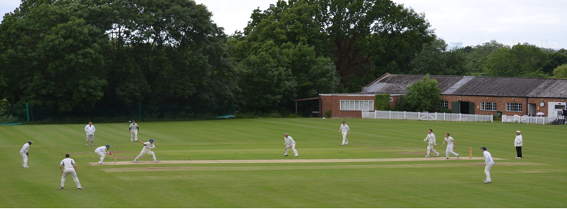
Streatham & Marlborough Cricket Club
SMS – 28 June 2018

FIXTURES | RESULTS |  | MEMBERSHIP | KIT |  | PAVILION
(Click for further information)

Welcome to the Streatham & Marlborough Sweep (SMS) – the latest information from SMCC

Pavilion News
More donations are coming in and we now stand at almost £18k (inclusive of Gift Aid) from the fundraising done in 2018 to go with the £40k raised in 2014. An excellent effort!
For those still to donate or those who want information – please click on “PAVILION” above. You can also find Gift Aid forms here for those who have already donated – it’s an extra 25p in the pound courtesy of HMRC so makes a big difference!

Overview of last weekend
More breath-taking cricket over the weekend. 1s and 4s winning by 1 wicket… 6s losing by 1 wicket… along with another comfortable win by the ladies… highlights were 60 from Chris Hobbis and 6-25 from Avin Ramani. (J Sbresni)

The juniors had a tougher weekend only recording two victories in seven. Several close run games though… (D Cook)

Grant Success

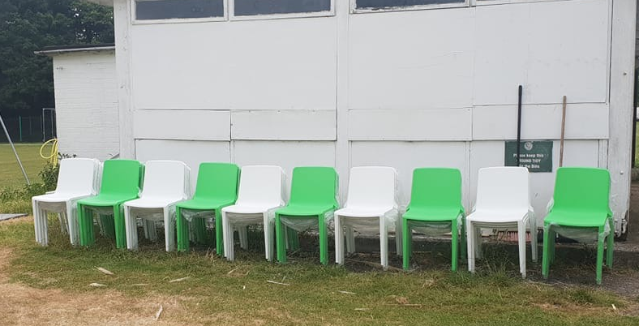 | Earlier in the year, we submitted a grant application to the ECB for additional seating in order to make the club more welcoming for its members and guests. This was especially required given the exponential rise in junior members and the success of Friday night training.  We were recently informed of its success and have now taken delivery of six additional wooden bench tables as well as 40 outdoor chairs. The new chairs should be significantly stronger than the plastic garden chairs we had previously.  Thanks go to Dan Johnson for doing the hard yards on this one.  An appeal from the groundsmen, please keep the tables and chairs tidy (ideally similar to the photos). This will best enable them to maintain the ground easily. The tables, especially, are heavy to move on your own…
Selection

Please send your availability for the upcoming fixtures (specifying Wednesday, Saturday and/or Sunday) to the various captains or our Chair of Cricket (Justin Sbresni - justin@busbyproductions.com / 07951 601 948) before Monday evening on the week of a game. If we haven’t heard by then, we will assume you are unavailable to minimise disruption later in the week.

Men’s and Ladies Summer Training

Men’s and ladies senior training will continue on a Thursday evening at the club (Dulwich Common, SE21 7EX) from 18.30 and will continue (weather allowing) until the end of the season.

Please note that the men’s sessions are being run by 1st XI skipper and Surrey CCC Coach, Neneto Davis.

Social Calendar

14 July | Club social hosted by the 2nd XI
21 July | Club social hosted by the 5th XI
28 July | Club social hosted by the 1st XI
18 Aug | Club social hosted by the 6th XI
26 Aug | President’s Day
1 Sept | Final League Games Party hosted by the 4th XI
15 Sept | Junior End of Season Awards
20 Oct | Senior End of Season Awards “Dinner & Dance”
24 Nov | Annual General Meeting

If you have any questions, please let me or another member of the committee know.
Cheers,
Dan
Men’s Club Captain

Proudly supported by:
Upcoming Fixtures: 28 June – 4 July

Date | Start | Team | Opposition | Venue
Saturday 30 June | 12:00 | 1st XI | Old Rutlishians | Home
 | 12:00 | 2nd XI | Camberley | Away
 | 13:00 | 3rd XI | Valley End | Away
 | 13:00 | 4th XI | Sunbury | Home
 | 13:30 | 5th XI | LESSA Christ Church | Home
 | 13:30 | 6th XI | New Ash Green | Away
Sunday 1 July | 13:30 | Ladies 1st XI | Purley Redoubtables | Home
 | 13:00 | Sunday 1st XI | Catford Cyphers | Home
League Fixtures can be viewed on our Play-Cricket site

Results: 21 -27 June

1st XI
Won by 1 wicket
Cheam 205-9 (50) / SMCC 210-9 (47.3)
1st XI League position – 7 / 10
Report: Six off the last ball to win last week was trumped by a six to win, nine wickets down this week. We like to keep it interesting…

With Captain Neneto “a bit” late, it was important that we won the toss. We lost… It’s funny how the departure of one player can have such an impact when trying to plug gaps in the field. Those gaps started to look like chasms with Cheam 35-0 off four overs… Then the breakthrough, Otis inducing a thin nick. One brings two, Raj bowling the other opener. Suddenly, the spinners have the ball on a string and the scoring rate decreases from 8s to 4s in quick time as they strangle the middle order. Allardice the pick of the three returning 14-2-27-2, he was ably supported by Singh (12-1-42-2) and JRao (8-0-48-2). 40 overs in, after encountering every red light in South London and only stalling a handful of times, Neneto joined us. His presence inspires a lower order wag which was only pegged back by Gibbens (4-0-15-2) who bowled well at the tail. An attacking declaration gave us 51 overs to chase down 206.

The response was a real team effort surrounding a selfless knock at the top from CHobbis (60). First he blunted the Cheam pace attack before battling injury to eek out runs to close the gap. However, when he fell with 18 remaining and 1 wicket remaining, it was advantage Cheam. Following a spicy game last year, Otis received a “welcome” to the wicket. Six. Went like a tracer bullet a yard above long on’s hand. Four through midwicket. The chat quietens. Raj plays a sensible hand leaving the ball where possible and nicking a single. Another two boundaries and a single brings us one short. Should they have run two leaving Raj on strike but the scores level? Otis has other ideas. The spinner rips one past the edge. A noise and a monumental appeal goes up. Umpire has to give it. NOT OUT! Toys everywhere. The spinner fires in another arm ball and Otis uses his railway sleeper to hit handsomely over the midwicket boundary. Is there any other way of winning the game?!

A great team effort with everyone contributing. They are enjoyable teams to be a part of. (D Ellis)

Ladies 1st XI
Gap Week
Ladies 1st XI League position – 2 / 4
Report: N/A

Ladies Trust XI
Won by 5 wickets
Sutton 141-8 (30) / SMCC 145-5 (25.5)
Ladies Trust XI League position – 2 / 10
Report: N/A

2nd XI
Lost by 6 wickets
SMCC 134ao (42.1) / Egham 135-4 (39.3)
2nd XI League position – 5 / 10
Report: N/A

3rd XI
Lost by 7 wickets
SMCC 182-9 (55) / Banstead 183-3 (35)
3rd XI League position – 7 / 10
Report: N/A

4th XI
Won by 1 wicket
Banstead 122ao (29.2) / SMCC 124-9
4th XI League position – 3 / 10
Report: It was never in doubt. Not ever.

The 4s mustered at Banstead’s tree lined ground in good spirits following the ‘Miracle of Morden’ – recovering from 17/6 to beat Old Ruts by more than 100 runs the week before.

Almost as miraculously, we won the toss, and stuck the oppo in, giving an out of nick top 6 some appreciated respite.

Banstead started positively, if streakily with the openers both clearing 4th team cricket’s elite slip cordon on a number of occasions, with some good shots in between.

A change of ends for the openers got immediate results – a line and length ball from Avin was creamed straight to backward square leg, where Rhys held a sharp chance. We were up and running, as from 30/0 of 7, the oppo lost wickets regularly.

More specifically, Avin was up and running: South London’s most likeable stock broker bowled with relentless accuracy and just a little nibble to end up with 35/6 from 11 overs – including the first six wickets to fall. Avin was ably backed up by the skipper Glazier (3/23), Jamie Fryer (1/12).

All the bowlers benefited from a sparkling fielding display. Apart from your humble correspondent, all chances were taken, including some sharp catches by Jack Hughes (3) and the skip (3). Together this was a mighty impressive fielding and bowling display on a flat track with a rapid outfield – anything that beat the ring ran away for 4.

Banstead all out 122.

Tea not being ready, we cracked straight on, with Stuart launching the opening bowler over his head in customary fashion off ball 6.

Banstead, however, were not ready to lie down and were a strong bowling side at this level. James, Greenwood, and Williams all departed before tea, which was reached at 55/3.

After some delicious onion pakoras and some juice diluted to Hughes’ approved proportions, we began well again after the interval, cruising to 65/3 with Perkins (19) and Hughes (24) in particular timing it sweetly.

Two events conspired against a seemingly inevitable win. Firstly, and somewhat surreally, Jack slapped a short ball to the long leg boundary before unceremoniously treading on his stumps.

If the oppo had a sniff at 4-down, they had a nose worthy of some unwashed cricket whites when their best bowler returned to remove yours truly and the skipper, who looked in good touch for his 10.

All of a sudden it seemed a familiar tale, with S&M in the hole at 80/6 still needing 43 to win.

The remaining 43 runs conspired to provide an epic, nerve jangling conclusion, as Banstead now felt victory within their grasp, and with tails lifted, finally began to look like a team. As we lost our heads, subsiding to 95/8, there was one main who kept his cool.

Never have the mere numbers been so inadequate. AD’s innings may only say 11* in the book, but it was worth triple that, as he blocked, accumulated singles and extras, guided his partner through, tired out their best bowler before, finally, we were home with one wicket to spare.

Along the way, Jamie Fryer timed the ball sweetly for 9, before being bowled leaving it (he should have actually left this one), and Olly Collard kept his nerve to clatter a full bunger to the fence to seal the win.

And finally, at 115/9 we thought we had lost it, as AD’s one mistake gave a chance to gully that was dropped at the fifth attempt.

It was never in doubt. Not ever.

Having moved to an unprecedented 3rd in the table, we retreated to the club, fingernails chewed to the bone. (O Perkins)

5th XI
Lost by 20 runs
NatWest 157ao (30.1) / SMCC 137ao (42.4)
5th XI League position – 6 / 8
Report: “I’m completely out of breath.”

I’ve had a long, sweaty afternoon under Paul Henly; I’ve got bruises I cannot explain to my partner; and I’ve just had a shower that feels like I’ve been scrubbed down and whipped with birch branches by a Turkish bath attendant whose mind is more on his martial issues than my wellbeing. But it’s the cricket – and its wonderful theatre – that leaves me gasping for air.

NatWest opt to bat first on a dry track and arid outfield, and launch a brutal attack on anything they deigned worthy of contempt. Whoosh, swish, and KABOOM, as the ball whizzes across the turf into the surrounding topiary. Replacement ball required in the third over.

“83 off 12 overs. Oh, f…”

But don’t let statistics fool you. For as their run rate is written in large letters on their Brexit Bus, scan down the scoreboard and you see 83-3, then 83-5, and then 93-8! A strange hubris is taking over, as good balls are routinely shovelled to orthodox fielding positions. In truth, we take nine – yes, NINE – excellent catches. Those who see Jim Hughes’s three will imagine it in black and white grainy newsreel, so they can show it to their imaginary grandchildren as an example of the golden age of flowing locks, baggy caps, and electrify fielding.

“What are they doing?!”

Steve Horlock is the pick – his 4-25 rips apart NatWest’s innings, with David Cook's 2-30 and your correspondent’s 3-24 leaving them reeling. The skipper looks aghast at the non-striker’s end, but decides to go down guns blazing, unpacks the golf clubs and continues flaying the bowling as before. His innings is dashing, and he adds 64 more swashbuckling runs. But 157 to chase, and 9 extra overs in which to do it should pose no issues.

“Don’t do what they did”

Sage advice, skipper. And we don’t. Well, not exactly. Our huge batting collapse includes very few runs at all, in fact. Being honest, the NatWest bowling is tight, but some concrete feet, a spinning pitch, and one lunatic’s suicidal running leaves us 23-5.

“I’ve never been in a game where we’ve been bowled out for less than 50.”

But this kind of comment doesn’t come from messrs Derbyshire, Sherpa (both 31) and Horlock and McWilliam (pleasingly, both 16). Each stride out with a freedom from pressure, and play with authority, move their feet and start pushing the field back to the ring, then the boundary, and then that same hedgerow we’d gone into too often. Steve and Luke play well straight, Alan slaps the ball wherever midwicket isn't, and Michael flicks anything over the fine leg boundary, as the chuntering bowlers have to chase another one towards the pavilion. The runs are mounting. The wickets aren’t falling!

NatWest look nervous. You sense it from the constant field changes and the arguments between overs. We are only 10 runs away. Let’s practise that handshake at the end – “GREAT GAME!” No, too smug. “Oh, good effort!” No, too patronising. “Cheers”. Yes, that’ll do.

“It’s the belief that kills you…”

They say it only takes ten good balls. Well, it only takes five if you bat like our top order. So within the space of two minutes, the game is over. Two straight ones mean the great escape is off. Steve McQueen snags a tire on the barbed wire, and is now teaching Home Economics in the Ruhr Valley. We don’t win, and I’m gutted. But this is why we love the game. That even in defeat we can still rejoice in how we got there.

“Let’s smash those guys next week...” (M Nicholas)

6th XI
Lost by 1 wicket
SMCC 114ao / Shooters Hill 115-8 (24.4)
6th XI League position – 6 / 9
Report: One gets bored of heroic failure. Noble defeat. I was brought up to despise all that public school tosh about the taking part...its winning that matters. Yet age, decay and the realities of playing 6th XI cricket bring a person to amore rounded view of life. But still...

Losing the toss and being put in determined our day along with another one of Kirk's late arrivals. To be fair to him who would have thought there would be traffic in South London on a Saturday in June. A hastily rearranged batting orders ruined several people's weekends and lost us the game probably. 5 for 4 in the third over really didn’t look that clever and it was a minor miracle that we rallied to 114 all out of 34 overs. A freakish roll back of the ball dislodged unlucky Russell Mueller's bail and Tony Hewitt got a nasty one that jumped and ballooned up. Stan was run out for the second week which is a sign of advancing years or terrible calling or something. Kirk arrived and put on 44 for the 5th wicket with Mohamed Wahla who again hit some mighty blows until giving away on 20. Kirk went on to reach 45 with support from the tail. Unlucky Gohar was bowled off what was surely a no ball but Stephen Harvey batted well for 17 before Barrington Wilks realising he had few remaining opportunities to run someone out ran Stephen out and left himself stranded after hitting another mighty boundary. Another fine spell of bowling from Arry Nelson who knows what he's doing and does it every week.

No point pussyfooting about we went after it with attacking fields. Shooters Hill being well aware of the dangers of chasing a small total also went after it. Barrington took 3 wickets as did Mohamed Wahla ably supported by fine fielding. Two great catches from Gohar Shafique at long off, a very sharp one by Tony Hewitt at cover point and two for Stan behind the stumps off Mohamed Wahla's inspired fast leg break. Both bowled to plans pre-arranged with the very part time keeper, both obligingly top-edged against the spin in to the gloves. Stephen Harvey bowled well and look a prospect, Sundar tried everything as usual and was very unlucky not to cling on to a very sharp return catch from the eventual game winner, Tom Foster, who batted beautifully for his 43 not out, marshalling the tail, working the strike, playing elegantly in a classical style and keeping his calm as wickets tumbled. We could not get him and so Shooters Hill triumphed by one wicket in the 24th over.

A very good bunch of guys Shooters Hill. Another tight game in glorious sunshine. A lot better result than had seemed possible at 2pm as it looked increasingly likely that we would be done in time to see the 4pm kick off. Scant consolation really. (L Johnston)

