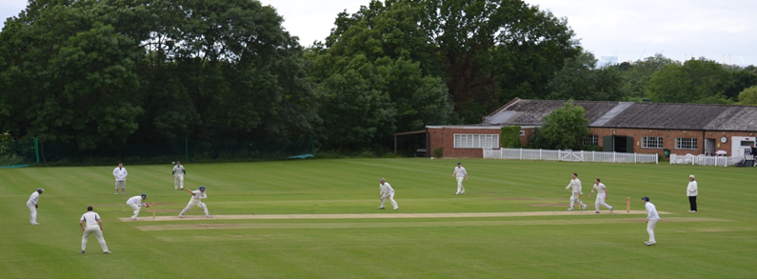
Streatham & Marlborough Cricket Club
April Update – 23.04.2018

FIXTURES | RESULTS | MEMBERSHIP | KIT
(Click for further information)

Dear all,

Finally, we managed to play some cricket in glorious weather at the weekend and hopefully you managed to enjoy the improvements made to the pavilion. Much of the hard work has been done by the current joint Club Person of the Year, David Brown and Brown Building - an important supporter of the club. Please remember that the (newly improved) club is available to hire so recommend far and wide as this is an important source of income!

A few important notices follow but, as ever, the quickest way to keep informed are via our Facebook Group (not to be confused with our less used Facebook page) for updates and Twitter feeds so please do join/follow.

Club Code of Conduct

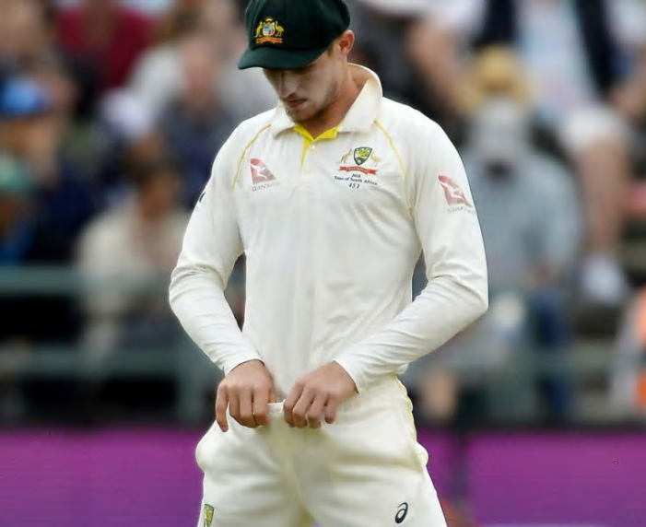 | Following a few incidents last year, the club have updated our Code of Conduct (attached) and would remind players to observe this whilst representing or visiting the club. A physical copy can be found on the noticeboard.  We consider ourselves an inclusive, friendly and welcoming club – let’s all do our bit to make sure that everyone feels that way. Any form of discrimination or poor conduct will be dealt with appropriately.

Membership

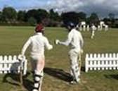 | UPDATE: Only 24 senior members have paid as of Friday – please can we get that number up…  More details can be found here but the club would like to re-iterate that cost will not be a barrier to play and anyone requiring assistance should contact the membership secretary, Dan Johnson (daniel.johnson11@nhs.net), to discuss.  Returning members can access ‘early bird’ pricing in April so grab yourself a discount! New members can access ‘early bird’ pricing throughout their first season with the club.

Match Fees

In addition to the Membership fee, a “match fee” is applied to all players for each game and covers the costs associated with the game (ground prep, tea's, balls, officials and so on). This applies to friendly and league cricket at the rate of £12 per match (or £6 for concessions).

You can obtain a discount by buying in bulk and paying in advance. There is £2 discount on a full rate (i.e. £50 for 5 matches, £100 for 10 matches) and a £1 discount for concessions (£25 for 5 matches, £50 for 10 matches).

Selection

In short, our intention is to select a strong, well-balanced side to give a fair and equal opportunity for all XIs to perform. We ask that players play where selected to the best of their ability and uphold the club’s code of conduct when representing the club.

You can help by sending your availability for the upcoming fixtures (specify Wednesday, Saturday and/or Sunday) to the various captains or via our Chair of Cricket (Justin Sbresni - 07951 601 948 / justin@busbyproductions.com) before Monday evening on the week of a game. If we haven’t heard by then, we will assume you are unavailable to minimise disruption later in the week.

Men’s Winter Nets / Men’s and Ladies Summer Training

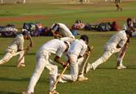 | We have two more remaining indoor sessions at the Kent CCC Indoor School on Worsley Bridge Road, Beckenham BR3 1DR.  This session runs as follows and the cost is £10 (£5 concessions):  Tuesday 24/04 8.30pm – 10.00pm  Tuesday 01/05 8.30pm – 10.00pm  With the ground firming up, men’s senior training will take place on a Thursday evening at the club (Dulwich Common, SE21 7EX) from 18.30 and will continue (weather allowing) until the end of the season. Outdoor training will start officially on 3 May but nets are available to use from now – juniors have priority on Tuesday and Friday evenings. Ladies training will also take place on a Thursday evening and started last week. All are welcome.

Social Calendar

5 May | New Member Drinks hosted by the Ladies XI
19 May | Club social hosted by the 3rd XI
27 May | Karen Goodchild Memorial Game
16 June | “Final Push” Pavilion Fundraising Party
14 July | Club social hosted by the 2nd XI
21 July | Club social hosted by the 5th XI
28 July | Club social hosted by the 1st XI
18 Aug | Club social hosted by the 6th XI
26 Aug | President’s Day
1 Sept | Final League Games Party hosted by the 4th XI
20 Oct | Senior End of Season Awards “Dinner & Dance”
24 Nov | Annual General Meeting

If you have any questions, please let me or another member of the committee know.
Cheers,
Dan
Men’s Club Captain

Proudly supported by:

Pre-Season Fixtures

Date | Start | Team | Opposition | Venue
Saturday 28 April | 13:00 | 1st XI | Old Whitgiftians | Home
 | TBC | 2nd XI | Cheam | Away
 | 13:00 | 3rd XI | Old Whitgiftians | Away
 | 13:00 | 4th XI | Battersea Ironsides | Home
Sunday 29 April | TBC | Ladies 1st XI | Godalming (league) | Away
 | 13:00 | Sunday 1st XI | Spencer | Home
 | 13:30 | Sunday 2nd XI | Greenleaf | Home
Saturday 5 May Onwards - League Fixtures can be viewed on our Play-Cricket site

