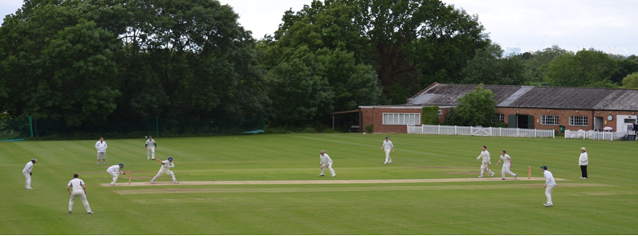

**Streatham & Marlborough Cricket Club**

**April Pre-Season Update – 04.04.2018**

Dear all,

The recent rain has meant that this weekend’s opening fixture has been cancelled. I’m not optimistic for the following weekend’s fixtures but will update you on this, along with any plans for training, as I find out.

In the meantime, [CricketForce](https://www.ecb.co.uk/be-involved/club-support/club-events/natwest-cricketforce) will take place this weekend and there is plenty to be getting on with so **please do offer some of your time** in order to make your club a nicer place to be!

**CricketForce 2018**

|  |  |
| --- | --- |
| cid:image005.jpg@01D3CC21.2AF235E0  cid:image003.jpg@01D3CC2E.D242C730  cid:image010.jpg@01D3CC2E.D242C730  cid:image012.jpg@01D3CC2E.D242C730 | **Saturday 7 April and Sunday 8 April           10am – 5pm**  NatWest CricketForce is a nationwide initiative aimed at cricket clubs to ensure grounds and facilities are ready for the new season. Last year, [we kicked off CricketForce](https://www.ecb.co.uk/news/356932) nationally and made some substantial improvements to the facilities, [as you can see here](http://streathammarlboroughcc.co.uk/index.php/gallery/). This year, we plan to build on the progress made in 2017 and hope to see many of you there.  To give you a very brief idea of what we want to achieve this year:   1. Remove all the brambles from the bank beside the top pitch 2. Paint the fencing nearest the car park 3. Assist with assembling the sightscreens and covers 4. Prepare the nets for use 5. Strim, cut and tidy the peripheral areas of the club 6. Some painting and a general tidy up   And much more…  It’s also a great opportunity to see the work which has been going on to improve the facilities over the winter.  Please report to Raj, David Brown or myself upon arrival to see what needs doing, wear clothes you don’t mind getting dirty and please bring secateurs and garden gloves if you have them! |

If you have any questions, please let me know. Otherwise, I hope to see you at the weekend!

Cheers,

Dan

Men’s Club Captain

[](http://www.streathammarlboroughcc.co.uk/)

Proudly supported by:  
[](http://www.brownbuilding.co.uk/)[cid:image021.png@01D2B90A.9B143510](http://www.mirash.co.uk/)

[cid:image025.png@01D2B90A.9B143510](https://www.facebook.com/groups/SMCricketClub/)[cid:image026.png@01D2B90A.9B143510](https://twitter.com/smcricketclub?lang=en)