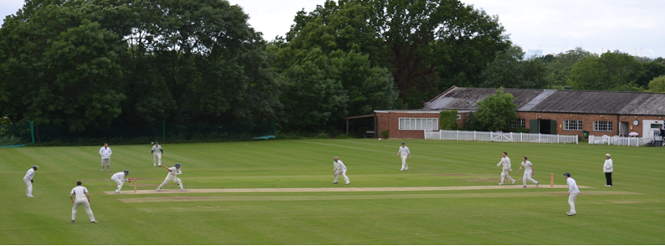

**Streatham & Marlborough Cricket Club**

**March 2018 Update**

Given last weeks cold snap, it’s hard to believe that the season is just a month away! With that in mind, please see the following updates with a list of upcoming fixtures at the bottom of this mail. Lots to cover…

**CricketForce 2018**

|  |  |
| --- | --- |
| cid:image011.jpg@01D3B60E.FF6C4780  cid:image012.jpg@01D3B60E.FF6C4780 | Last year, the Club kicked off [CricketForce](https://www.ecb.co.uk/be-involved/club-support/club-events/natwest-cricketforce) nationally – for info, see [The Guardian](https://www.theguardian.com/cricket-has-no-boundaries/2017/jul/19/save-our-stumps-how-cricketforce-came-to-the-rescue-for-uk-clubs) and this [ECB video](https://www.youtube.com/watch?v=vQgPTzADHf4) - and made some substantial improvements to the facilities with almost 200 volunteers doing their bit. This year, we plan to continue the improvements and we hope to see many of you there. Planning for the event (**date to be confirmed shortly**) is taking place and we would love to hear if anyone is interested in getting involved – always wanted to see secure bike parking? Think that an insect repellent to stop the midges biting whilst you enjoy the last of the days sunshine would be money well spent? Now’s your chance to have a voice.  Please contact Raj Patel ([rajnaldo@aol.com](mailto:rajnaldo@aol.com)) who is heading up the project… More details to follow. |

**SMCC Featured in new NatWest Cricket Advert**

|  |  |
| --- | --- |
| [cid:image019.jpg@01D3B60E.FF6C4780](https://t.co/CjlE9LUypG) | The eagle-eyed of you will spot that the Club and a number of our members feature in the latest NatWest Cricket advert released yesterday. For the full clip, please click [here](https://t.co/CjlE9LUypG). |

**Club Sponsorship**

|  |  |
| --- | --- |
| cid:image020.jpg@01D3B60E.FF6C4780 | I had been hoping to update you fully but we’re not quite at that stage. I can say we have two interested parties and should have further information by the end of next week.  If anyone else has any leads, please do let me know and we can discuss what packages we can provide. |

**Men’s Winter Nets / Men’s and Ladies Summer Training**

|  |  |
| --- | --- |
| cid:image013.jpg@01D2B90A.9B143510 | The final men’s indoor net session takes place on 25 March - unfortunately, I’ve been unable to extend the booking due to lack of availability.  As soon as the ground firms up, both the men and ladies section will switch their training to a Thursday evening at the club (Dulwich Common, SE21 7EX) from 18.30 and will continue (weather allowing) until the end of the season. All are welcome. |

**Membership**

|  |  |
| --- | --- |
| [cid:image010.jpg@01D2B386.6E2A2110](http://www.streathammarlboroughcc.co.uk/index.php/membership/) | We are now able to start accepting membership fees for the 2018 season. [More details can be found here](http://streathammarlboroughcc.co.uk/index.php/membership/) but the club would like to re-iterate that **cost will not be a barrier** to play and we will continue to cater for no / low income members requiring assistance on a case-by-case basis.  A reminder that our membership secretary changed at the last AGM so please contact Dan Johnson ([daniel.johnson11@nhs.net](mailto:daniel.johnson11@nhs.net)) with any queries. |

**Selection**

|  |  |
| --- | --- |
| cid:image008.jpg@01D2B386.6E2A2110 | For the benefit of new members (and a reminder to existing members), I’d like to take the opportunity to present the club’s selection principles (attached). In short, we intend to select a **strong, well-balanced side** to give a **fair and equal opportunity for all XIs** to perform. We ask that players **play where selected** to the best of their ability and **uphold the club’s code of conduct** when representing the club. |

**Club Discount – Woodstock Cricket**

|  |  |
| --- | --- |
| [cid:image007.png@01D2C42A.AE4E8E20](http://www.woodstockcricket.co.uk/) | If you need any kit, the Club has an arrangement with [Woodstock Cricket](http://www.woodstockcricket.co.uk/) who I can personally recommend having used them for a number of years. For a more learned opinion on the quality, [Wisden Gear Test 2018](http://www.thecricketer.com/Topics/features/the_cricketer_good_gear_guide_2018_we_test_the_latest_bats_on_the_market.html) placed them third overall to add to wins and second places in previous years - high praise indeed.  The discount works out to be roughly 35% but I’ll be happy to provide a full price list for those who want to look further. |

As ever, if you have any questions, please let me or another member of the committee know.

Cheers,

Dan

Men’s Club Captain

[](http://www.streathammarlboroughcc.co.uk/)

Proudly supported by:

[](http://www.brownbuilding.co.uk/)[cid:image021.png@01D2B90A.9B143510](http://www.mirash.co.uk/)

[cid:image025.png@01D2B90A.9B143510](https://www.facebook.com/groups/SMCricketClub/)[cid:image026.png@01D2B90A.9B143510](https://twitter.com/smcricketclub?lang=en)

Upcoming Pre-Season Fixtures

|  |  |  |  |  |
| --- | --- | --- | --- | --- |
| **Date** | **Start** | **Team** | **Opposition** | **Venue** |
| Saturday 7 April | 13:00 | Combined 1st / 2nd XI | Catford & Cyphers | Away |
|  |  |  |  |  |
| Saturday 14 April | 14:00 | 1st XI | Catford Wanderers | Away |
|  | 12:30 | 2nd XI | HSBC | Home |
|  | 13:00 | Inter-club Fixture | N/A | Home |
|  |  |  |  |  |
| Sunday 15 April | 13:00 | Sunday 1st XI | Mpingwe | Home |
|  |  |  |  |  |
| Saturday 21 April | 11:30 | 1st XI | Malden Wanderers | Away |
|  | 13:00 | 2nd XI | Bexleyheath | Home |
|  | TBC | 3rd XI | Dulwich | Home |
|  | 13:00 | 4th XI | Purley | Away |
|  |  |  |  |  |
| Sunday 22 April | 12:30 | Sunday 1st XI | Jesters | Home |
|  |  |  |  |  |
| Saturday 28 April | 13:00 | 1st XI | Old Whitgiftians | Home |
|  | TBC | 2nd XI | Cheam | Away |
|  | 13:00 | 3rd XI | Old Whitgiftians | Away |
|  | 13:00 | 4th XI | Battersea Ironsides | Home |
|  |  |  |  |  |
| Sunday 29 April | 13:00 | Sunday 1st XI | Spencer | Home |
|  | 13:30 | Sunday 2nd XI | Greenleaf | Home |
|  |  |  |  |  |
| Saturday 5 May Onwards | | League Fixtures can be viewed on our [Play-Cricket site](http://stmcc.play-cricket.com/website/web_pages/112572) | | |