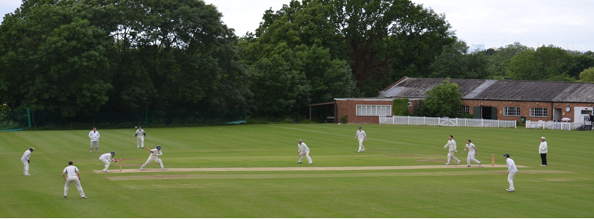
Streatham & Marlborough Cricket Club
February 2018 Update

Firstly, a warm welcome in this cold snap to a number of new potential members (38 and counting!) who have contacted the club in the close season. There are just a few items to update you and the existing members on.

- Men’s nets are underway and have been exceptionally well attended so far. We are aware that, on some occasions, we may even have too many people attending (a great problem to have!) and will continue to monitor with a view to sourcing an additional venue. More details on the nets can be found here.

- Ladies nets started two weeks ago and they have sent an appeal (featured below) to all members to try and boost their numbers given they will be entering a second team this year. Please help spread the word!

- Our Chairman, John Greenwood, has been hard at work over the winter preparing and submitting applications to Sport England and the London Marathon Charitable Trust in order to raise funding for a new pavilion. These were submitted a couple of weeks ago with the result only known later in the year so fingers crossed for a favourable outcome. A phenomenal amount of work goes into these applications so we are very appreciative of John’s efforts! For the benefit of new member (and a refresher for existing members) more detail on the pavilion appeal can be found here on the Pavilion page of our website

- Unfortunately, we found out in November that our main club sponsor, Bilmes LLP was to be closed and could no longer continue it’s association with the club. This is obviously a financial blow to the club as the previous agreement was worth over £3,000 p.a. We have been in discussions with a few interested parties but are yet to come to any agreement. If anyone knows of someone or a firm that may be interested, please let me or any member of the Executive Committee know.

- Many of you will be aware we suffered a break-in recently. Last week we heard that the culprit was apprehended and given a 12 month custodial sentence. We hope to have the repair work completed shortly.

In news elsewhere around the club, the junior training sessions remain exceptionally well received in their new format and that section is hopeful of a successful season.

Appeal for new ladies members

After the fantastic success of last season, the ladies team is on the up and this year will be entering teams into two leagues - the 1st X1 in the Southern League, and Development X1 in the Surrey Trust League.

There couldn't be a better time to join us, and that's where we need SMCC Club members help! We desperately need some new players of all ages and abilities. We cater for all - whether played club /uni cricket, a keen sportsperson and wanting to try something new, or completely new to the game!

Please encourage your friends, family, parents, other halves, colleagues, tinder dates, neighbours etc to give it a go. Perhaps you're at uni / finished uni and there's a women's section - any of them in London for the summer / moving to London? Or you have a sporty colleague or two who may want to try a new sport? Please spread the word and direct them to us via Emma (emmawilliams13@icloud.com) or Kathryn (kathryntharby@gmail.com) for more info.

Plus, there's a free beer or two on offer courtesy of the ladies for anyone who recruits us a new member :)

Winter training is taking place every Sunday (except 18 February) from 6pm-8pm on Sundays at Alleyn's School until 28 March - we'd love to see some new faces!

Please also follow us on Twitter and Facebook.

Proudly supported by:

