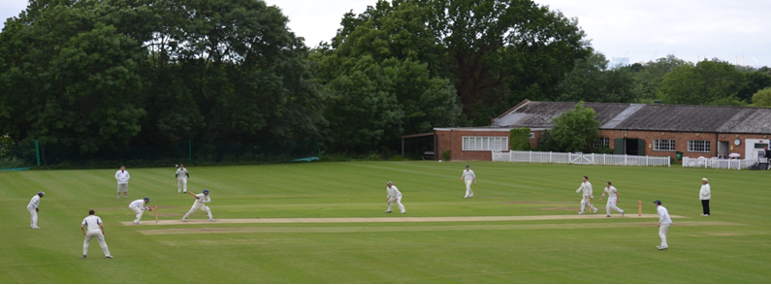
Streatham & Marlborough Cricket Club
Winter Nets 2018

Dear all

Happy New Year!

It’s time to dust off the kit as the men’s senior training starts this Sunday. There are further details below but I’ll just note that we’ve had a number of new enquiries from potential members which is very positive. We hope to see many new faces at training so please make them feel welcome, as per usual.

It is worth noting that the turnout at the first net last year was pretty high before settling to a more manageable number in subsequent weeks. We should still be able to get everyone a bat and a bowl but, if demand remains high, we will make provisions for additional nets or a booking system.

In news elsewhere around the club, the junior training sessions are going very well with a number making Surrey and/or London Schools squads whilst the ladies will start their training sessions in late January.

Finally, there is an Executive Committee meeting next week so if you’d like to raise anything, please let me or another committee member know.
Cheers,
Dan
Men’s Club Captain

Men’s Senior Winter Training

Winter nets will commence on Sunday 14th January 2017 at 11am. They will run on consecutive Sundays until the start of the season. The venue will be Dulwich College Preparatory School on Alleyn Park, the same venue as previous years.

As before, there’s no need to book so please feel free to attend as you like. We do, however, have to pay for the hall so need to collect a small amount of cash from those who attend. It’s £10 for those in full employment and £5 for concessions (i.e. unemployed, student, over 65s and those earning below London Living Wage) per session.

Dates: Every Sunday from 14 January – 25 March
Time: 11am - 1pm

For those that are new to the club, or new to cricket, please see below for some specific information on the club training so you know what to expect.

Proudly supported by:

SMCC Open Age Men’s Winter Nets

The venue is Dulwich College Prep School (42 Alleyn Park, London SE21 7AA). You need to go through two sets of doors at the main entrance and then follow the path to the right which leads to a sports hall. At the entrance to the sports hall, there will be someone to welcome you and sort the cash side of things. Cash only please although it is possible to do a bank transfer if really necessary.

At 11am, we’ll head into the halls and do some form of warm up before pulling the nets out. In the past, the stronger players generally occupy the nets at the far side of the hall but everyone is pretty happy to mix and match. For new guys, it’s probably best to take a quick look to see where you’ll fit in best and then jump in to a lane. I can happily report that the lads across the club are welcoming. If you don’t have any gear, someone in your lane will have kit he’s happy to lend. If you’ve got a ball, great, but no problem if not. There should be a bag of balls or one that can be borrowed. There’s no official coaching at these sessions.

Senior colts (U15 and above) are welcome to attend. Please note that the club makes every effort to maintain good general safekeeping practices but cannot guarantee there will be DBS checked members at every practice.

In terms of what to wear, a white top is preferably but anything which is comfortable will do. Trainers only as we’ll be inside.

