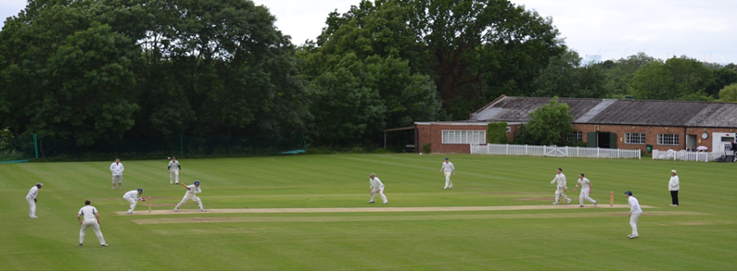
Streatham & Marlborough Cricket Club
Notice of Annual General Meeting
11 November 2017

Notice of Annual General Meeting – 11 November

The Streatham & Marlborough Cricket Club AGM will occur on Saturday 11 November 2017. Please make every effort to attend - this is your club and you can directly influence the direction that it takes. I would stress that it’s important to hear from all members whether you have been with us for one season or fifty. Every view counts.

After a (hopefully) quick meeting, there will be a Club night from 7.30 onwards! All welcome to attend, even if you can’t make the AGM earlier on…

Date: Saturday 11 November 2017
Time: 6 for 6.15pm (prompt start)
Venue: SMCC Clubhouse, Dulwich Common

More detail will follow but please see detail on the club officer roles below.

Proudly supported by:

Elections

Officers | Captains
President - Peter Edwards  (No re-election due until November 2019) | Men's Club Captain – Dan Ellis
Chairman - John Greenwood | Ladies Club Captain - Emma Williams
Honorary Treasurer - Eddie Goodchild | Junior Club Captain – Vacant
Club Development Officer - John Greenwood | 1st XI – Kasheef Hassan
Honorary Secretary - Karen Klomp | Ladies 1st XI - Rabiena Hassan
Fixture Secretary - Mark Bartolo | 2nd XI - Armani Sharif
Membership Secretary - Mark Bartolo | 3rd XI - Matt Clark / Dan Driscoll
Chair of Senior Cricket - Justin Sbresni | 4th XI – Vacant
Chair of Junior Cricket - Sally Keith | 5th XI - Laurie Johnston
Colts’ Development Officer – Kasheef Hassan | 6th XI - Vacant
Social Committee (Chair) - Vacant | Sunday 1st XI – Bobby Iftikhar
Welfare Officer – Liz Marin-Curtoud | Sunday 2nd XI – Vacant
League Representatives – Dave Gladstone (Surrey) / Laurie Johnston (Kent)  Dave stepping down | Midweek XI – Chris Reardon

Depending on the outcome of the vote to change the constitution – there may also be a new position created to provide more representation of the juniors section and the removal of the junior club captain which has often been left vacant.

Brief Role Descriptions:
President: This is an honorary position and has no specific role or responsibilities. However, there is normally an annual event held which the entire club is invited to.
Chairman: Overall responsibility for SMCC. Leads the committee in the management of the clubs affairs.
Treasurer: To act as the financial officer of the Club. To advise the executive committee with regard to the financial standing of the Club. To maintain accounting records of each financial year and present audited accounts prior to an AGM. To recommend to the executive committee any matters of finances in regard to income & expenditure. To suggest levels of annual subscription and match fee.
Club Development Officer: Looking at funding opportunities, how to develop the club and obtaining grants for equipment.
Honorary Secretary: To act as general correspondent for the Club. To record and distribute minutes of committee meetings, AGMs, EGMs & SGMs as necessary. To notify members and friends of the Club of all Club meetings and events in accordance with the rules.
Fixture Secretary: To arrange cricket matches for the number of teams elected at the AGM. To correspond with those teams during the course of the season to ensure fixtures are to be upheld. To advise details of venues to the Captains or Vice-Captains. To act as point of contact prior to the game should adverse weather prevail.
Membership Secretary: Responsibility for extending a warm introduction to all new players, liaising with the chair of cricket to ensure these players are offered games and collection / management of subscriptions.
Chair of Senior Cricket: Chair the weekly selection meeting during season ensuring adherence with the selection policy.
Chair of Junior Cricket: Overall responsibility for SMCC Junior Cricket. Leads the junior committee in the management of the clubs affairs.
Men’s Club Captain: Representative on the Executive for the Men’s playing section.
Ladies Club Captain: Representative on the Executive for the Women’s playing section.
Junior Club Captain: Representative on the Executive for Under 25's.
Junior Club Representative: Representative on the Executive for the Junior section.
Social Committee (Chair): To propose social events to satisfy the social calendar of the Club. To propose fund-raising events to fulfil the financial requirements of the Club. To organise agreed social and fund-raising events for the Club.
Welfare Office: To be responsible for the well-being of all Club young players participating in Club events To ensure that the Club adheres to the requirements and directives of all appropriate bodies regarding young players.
League Representatives (Surrey & Kent): To be the first point of contact for the League committee(s). To manage the supply of information to and from the League committee(s). To refer all related matters to the appropriate Club officer(s) at the earliest possible opportunity. To make all reasonable efforts to attend relevant League Meetings.

