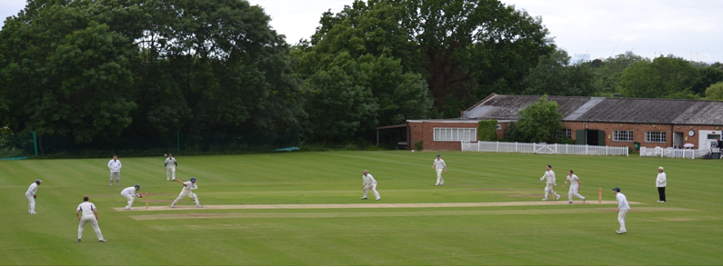
Streatham & Marlborough Cricket Club
Midweek SMS – 20 September 2017

Championes, Championes, Olé! Olé! Olé!

The Ladies 1st XI won their final game against Dulwich on Sunday to finish unbeaten as champions of the Surrey Trust League. A tribute to the hard work put in on and off the field over a number of years. Well done to Rabiena Hassan and her team. Throughout the season, there were a number of performances which stand out. With the bat… Verity (261 runs @ 87!), Sally (148 @ 29.6), Crystal (138 @ 46) and Mikaela (121 @ 30.25) performed admirably in a league where you are forced to retire at 35 runs. With the ball… Sally (16 wickets @ 7.4), Mikaela (13 @ 7.5), Crystal (10 @ 7), Dagmara (10 @ 10.2) and Verity (10 @ 16.1) took key wickets throughout. In the field, Verity, Lydia, Dagmara and Mikaela all contributed catches and run outs. However, it’s clear that this tight knit group came together as a team and played for each other. Lads, the template has been set…!

Another positive for the club worth noting as we head into the close season was the support for the End of Season Junior Awards last Friday. It’s so heartening to see this section of the club thriving and it’s in no small part to the countless hours organising by volunteers. For more information, see the Junior Cricket update posted earlier

Finally, a reminder of some upcoming events.

End of season renovation – 25 September

Please note that the end of season renovation on the square will now take place on Monday 25 September (and may stretch into Tuesday). If you are available to help with this labour intensive work, please contact Roger on 07551 967368.

We would also be grateful if members are around over the next few weeks to help put any equipment away for the winter months (e.g rope, sightscreen slats, nets, etc).

Surrey Championship Awards Dinner – 6 October

Once again taking place at The Kia Oval on Friday 6th October. This year’s guest speaker is Matthew Hoggard. We have 4 mandatory tickets and additional tickets can be purchased at £39.50 per head. Tables will be of ten on the evening.
Please contact me if you are interested in attending.
http://www.surreychampionship.com/2017-annual-awards-dinner-38863

End of Season Awards Dinner – 28 October

You may have seen so posters go up at the weekend – if not, I’ve attached one. Always a popular evening so book early to avoid disappointment! Please contact Natalie Hill (Natalie.Hill@Rothschild.com) or Dan Johnson (daniel.johnson11@nhs.net) before 21 October to reserve your spot and to provide names of guests. As ever, the food will be provided by the fantastic Alisha and her team.
Venue: Clubhouse, Dulwich Common
£35
Formal Dress Code
Partners / Friends / Family / First dates (especially) all welcome.
6.30pm till late
Club account details for online payment are:
Streatham & Marlborough CC
S/C: 20-80-57
A/C: 80617997
Ref: "D&D (Initial & Surname)"

Annual General Meeting – 11 November

As another season draws to an end, it’s already time to think about next year. Do you think you could help with a role either on the Executive Committee or as a captain? Have a gripe about something? Now is your chance…

Please do make every effort to attend - this is your club and you can directly influence the direction that it takes.

Best of luck to our all our players at the weekend.

Cheers,
Dan

Proudly supported by:

Ladies 1st XI
Won by 77 runs
Dulwich 92-8 (30) / SMCC 96-7 (25)
Ladies 1st XI League position – 1st / 12
Report: SMCC Ladies' long season finally came to an end on Sunday with a return fixture against local rivals Dulwich. The weather was once again cold and miserable but the team's focus was firmly on ending the season undefeated.

After a very professional warm up involving a football kick-about, SMCC took to the field first. Verity Quade and Dag Selwyn-Kuczera opened the bowling in heavy drizzle. A pumped-up Selwyn-Kuczera produced a fine spell of swing bowling and captured the prize scalps of Dulwich's best two batsmen, both trapped leg before having contributed almost nothing to the total. Selwyn-Kuczera finished her spell with strong figures of 6-1-12-3. SMCC put in an improved fielding performance, conceding just a single boundary in the whole innings. Victoria Bates in particular put in a sterling effort at fine man.

Kathryn Tharby was unable to replicate her golden arm performance of last weekend; nonetheless she still picked up two vital wickets employing that tried and tested technique of bamboozling the batsmen with an unpredictable mix of good and not-so-good balls. Tharby's bowling also effected a run out when the batsmen attempted to sneak a quick run off a particularly wide wide ball – smart thinking from Emma Williams behind the stumps led to the batsman being just short of her ground. Liz Marin-Curtoud and skipper Rabiena Hassan with her mystery 'spin' both bowled tidy spells to restrict Dulwich's scoring rate. In the end extras accounted for the top score out of a total of 92.

Following perhaps the most bizarre offering of a match tea (doughnuts, naartjies, some kind of unidentified hors d'oeuvre on a stick and no tea), SMCC began their innings hoping to chase down the Dulwich total without too much trouble. The innings got off to a tricky start when Emma Williams was adjudged out LBW – technically finger before wicket – following a suspiciously swift decision from the home umpire. The situation went from bad to worse when Quade was run out in horrible circumstances. Quade was, understandably, more than a little frustrated at being dismissed but she finished the season with 261 runs at a healthy average of 87. Sally Kent who had hit a couple of boundaries never really got going and was bowled for 16. Wickets continued to fall on a regular basis but Lydia Slack, making a very welcome return to the side, kept her nerve to compile a classy, unbeaten 30 to hold the innings together. Slack's innings featured six boundaries, including several powerful drives through the covers. Bates provided good support to Slack at the end and the pair saw SMCC home to eventual victory, after a few scares, in the 25th over.

Thanks go to Adrian Atherton for once again giving up his time to umpire for us with patience and good humour.

To paraphrase Emma Williams (and with apologies to Gaius Julius Caesar): we came, we saw, we critiqued the match tea, we survived a batting collapse, we conquered (just), we had more than a few pints and laughed about it all afterwards. We bossed this season. Bring on 2018!! (S Kent)

