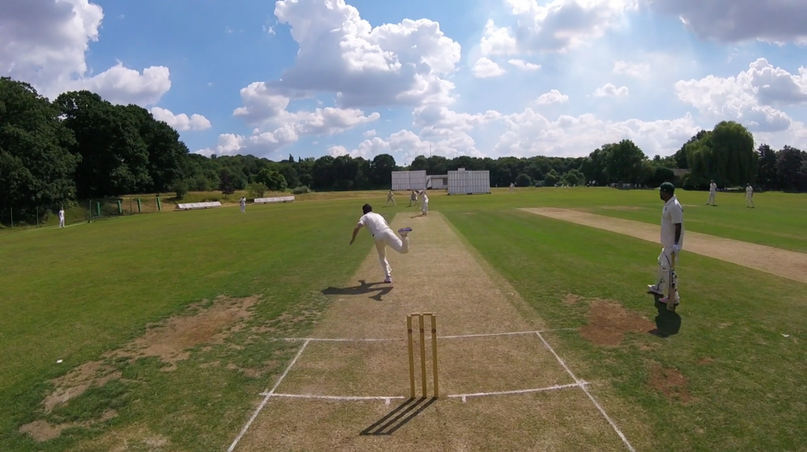

**Pre-Season 2019 Update**

Pre-season is well underway with lots of new faces at the club after another strong year of recruitment. The Women’s section start their league campaign next Sunday before embarking on a short tour to La Manga (9-12 May) whilst the Men’s section start their league fixtures on 11 May. The Junior section, now numbering over 200, started their training evenings (Tuesday & Friday) this week and will start their league matches this weekend. I will endeavour to keep you up to date with news from all sections as we go through the season.

As ever, we have a few updates to keep you well informed and we begin with a request…

**Have your say! Survey ends on 30 April**

|  |  |
| --- | --- |
|  | As we embark on a new season, please take a couple of minutes to help the committee serve the club more effectively by answering this very short [survey by clicking here](http://bit.ly/2ubu9lk). This will help shape the club’s future direction so it would be great to get a bigger sample than just the 15% or so that have completed it so far.  If you need any further information about club policies, development plans etc, please check the website. |

**Discount to membership fee ends on Monday!**

|  |  |
| --- | --- |
| image1.jpeg | Membership fees or “subs” are due by end of May but returning members can save themselves a few quid by paying before the end of April. Details of what and how to pay can be found [here for Men’s Cricket](http://streathammarlboroughcc.co.uk/index.php/men/) and [here for Women’s Cricket](http://streathammarlboroughcc.co.uk/index.php/ladies/).  If you want to discuss anything membership related (concessions, instalments, etc) please drop Dan Johnson a line on [enquiries.SMCricketClub@gmail.com](mailto:enquiries.SMCricketClub@gmail.com) or speak to him in person. |

**Karen Goodchild Memorial Game – 5 May**

|  |  |
| --- | --- |
| cid:image015.jpg@01D2CF27.C39BAF80 | As many of you will be aware, we lost the most wonderful lady three years ago. Karen was an integral part of the club and we will be hosting a memorial game to celebrate her life. All members are welcome (and encouraged) to attend.  The match will be played by two SMCC XI’s from 1.30pm. If you’d like to play, please contact Armani ([armani.sharif@hotmail.com](mailto:armani.sharif@hotmail.com)) or comment on this [club Facebook post.](https://www.facebook.com/groups/SMCricketClub/permalink/10156313766522194?sfns=mo) |

**Teamo app**

|  |  |
| --- | --- |
| image1.png | We’ve had a great initial sign up to our new Teamo app so thank you for signing up. This will be our main selection and match fee payment tool. The feedback has been pretty positive though I know there are a few frustrations. Please stick with the app as it will make the lives of our fantastic volunteers far easier as well as making the club’s finances far more robust and transparent.  [If you’re yet to register, you can do so by clicking here.](https://www.teamo.chat/club/register/smcc)  Please mail [enquiries.SMCricketClub@gmail.com](mailto:enquiries.SMCricketClub@gmail.com) with any issues with the app or Raj on [smccchair2019@gmail.com](mailto:smccchair2019@gmail.com) if you have any selection based queries. |

**Women’s Senior (Open Age) Training @ SMCC**

|  |  |
| --- | --- |
| [http://streathammarlboroughcc.co.uk/wp-content/uploads/2019/01/SMCC-Ladies-team-photo-1024x946.jpg](http://streathammarlboroughcc.co.uk/index.php/ladies/) | The women’s section have started their programme of outdoor training with new coach at the home ground. Sessions run from 6.30pm to 8.30pm on Thursday evening throughout the summer.  Contact Kathryn ([kathryntharby@gmail.com](mailto:kathryntharby@gmail.com)) or Emma ([emmawilliams13@icloud.com](mailto:emmawilliams13@icloud.com)) for more information. |

**Men’s Senior (Open Age) Training @ Kent CCC**

|  |  |  |  |  |  |
| --- | --- | --- | --- | --- | --- |
| [Image result for kent indoor cricket facility](https://www.google.co.uk/url?sa=i&rct=j&q=&esrc=s&source=images&cd=&cad=rja&uact=8&ved=2ahUKEwjIvty8uY7hAhURZ1AKHQd7AIAQjRx6BAgBEAU&url=https%3A%2F%2Fwww.buildingcentre.co.uk%2Fcase_study%2Fkent-county-cricket-club-bowled-over-with-gerflor&psig=AOvVaw2Nqm_ZQ5fT0ptDDGbGIQqF&ust=1553093273500219) | There are two remaining indoor training sessions for the men’s section at the fantastic [Kent CCC facility](http://www.kentcricket.co.uk/grounds/the-county-ground/) at the County Ground in Beckenham:   |  |  | | --- | --- | | *Tuesday 30 April* | *8pm to 9.30pm* | | *Tuesday 7 May* | *8pm to 9.30pm* | |
|  | Once the weather and surfaces at the ground become dry enough, we will host training at the club ground. Please keep an eye out for a start date. |

**SMCC Golf Day – 6 May**

|  |  |
| --- | --- |
|  | The SMCC golf day will take place on the early May Bank Holiday so please contact me if you’re interested in playing. As it stands, it looks like we’ll get about three groups out of varying abilities.  Cost will be around £25 and venue looking likely to be Woldingham GC or similar. |
|  |  |

**Cricket coming up**

|  |  |  |  |  |  |  |  |  |  |  |  |  |  |  |  |  |  |  |  |  |  |  |  |  |  |  |  |  |  |  |  |  |  |  |  |  |  |  |  |  |  |  |  |  |  |  |  |  |  |  |  |  |  |  |  |  |  |
| --- | --- | --- | --- | --- | --- | --- | --- | --- | --- | --- | --- | --- | --- | --- | --- | --- | --- | --- | --- | --- | --- | --- | --- | --- | --- | --- | --- | --- | --- | --- | --- | --- | --- | --- | --- | --- | --- | --- | --- | --- | --- | --- | --- | --- | --- | --- | --- | --- | --- | --- | --- | --- | --- | --- | --- | --- | --- |
| [http://streathammarlboroughcc.co.uk/wp-content/uploads/2010/10/29_bartolo-1024x684.jpg](http://streathammarlboroughcc.co.uk/wp-content/uploads/2010/10/29_bartolo.jpg) | |  |  |  |  | | --- | --- | --- | --- | | **Date** | **Team** | **Time** | **Opposition (Venue)** | | 27/04 | Saturday 1st XI | 12:00 | Kingstonian (H) | | 27/04 | Saturday 2nd XI | 12:00 | Bank of England (A) | | 27/04 | Saturday 3rd XI | 12:00 | Dulwich (A) | | 27/04 | Saturday 4th XI | 12:00 | Mitcham (H) | | ~~28/04~~ | ~~Women’s 1~~~~st~~ ~~XI~~ | ~~13:00~~ | ~~Stoke D’Abernon (A)~~ | | 28/04 | Sunday 1st XI | 13:00 | Spencer (H) | |  |  |  |  | | 04/05 | Saturday 1st XI | 12:00 | Chipstead (A) | | 04/05 | Saturday 2nd XI | 12:00 | Blackheath (H) | | 04/05 | Saturday 3rd / 4th XI | 12:00 | Intra-Club (H) | | 05/05 | Karen Memorial | 13:30 | SMCC XI (H) | | 05/05 | Women’s 1st XI | 13:00 | Guildford (A) | | 05/05 | Sunday 1st XI | 13:00 | Southwark (H) |   If anyone wants to know more about how selection works, please see the [FAQs on our main website](http://streathammarlboroughcc.co.uk/index.php/men/). For more league fixtures, please see our [Play-Cricket site](http://stmcc.play-cricket.com/website/web_pages/112572). |

In other news:

* A heartfelt thanks to those who volunteered some time over the CricketForce weekends. It’s very much appreciated and a lot was achieved to get things ready for play!
* The club are always on the lookout for scorers and umpires for all sections. If you want to try your hand, or know anyone that does, please let me know.
* Senior kit, featuring the logos of [Simon Wright Jewellery](https://sw-jewellery.com/) and [Brown Building](https://www.brownbuilding.co.uk/), can now be purchased from AllRounder Cricket by [clicking here](https://www.allroundercricket.com/teamwear/cricket-teamwear/s/streatham-and-marlborough-cc).
* It’s been rightly pointed out that the Women’s section are on tour during our opening social of the season to welcome all our new members. Apologies for some poor organising on my part there – 11 May will remain a post-game social and we hope to have arrange another social soon after to welcome all sections.
* Pavilion Update: we hope to have a design signed off by next week and with the planners by end of May. Timeline remains tight but we’re still pushing for a build over the winter. More detail [on the website](http://streathammarlboroughcc.co.uk/index.php/pavilion-project/).

As ever, if you have any questions, feel free to get in touch.

Best,

Dan

Men’s Club Captain

[](http://www.streathammarlboroughcc.co.uk/)

Proudly supported by:[cid:image009.png@01D4D421.050C79E0](https://sw-jewellery.com/)   [](https://www.brownbuilding.co.uk/)   [](http://www.mirash.co.uk/)

Follow us on:  
[cid:image025.png@01D2B90A.9B143510](https://www.facebook.com/groups/SMCricketClub/) [cid:image026.png@01D2B90A.9B143510](https://twitter.com/smcricketclub?lang=en) [](https://www.instagram.com/smcricketclub/)

Fundraise via:

[](https://www.easyfundraising.org.uk/causes/smcricketclub/)