Pre-Season 2019 Update

Extended Men’s Senior (Open Age) Training @ Kent CCC

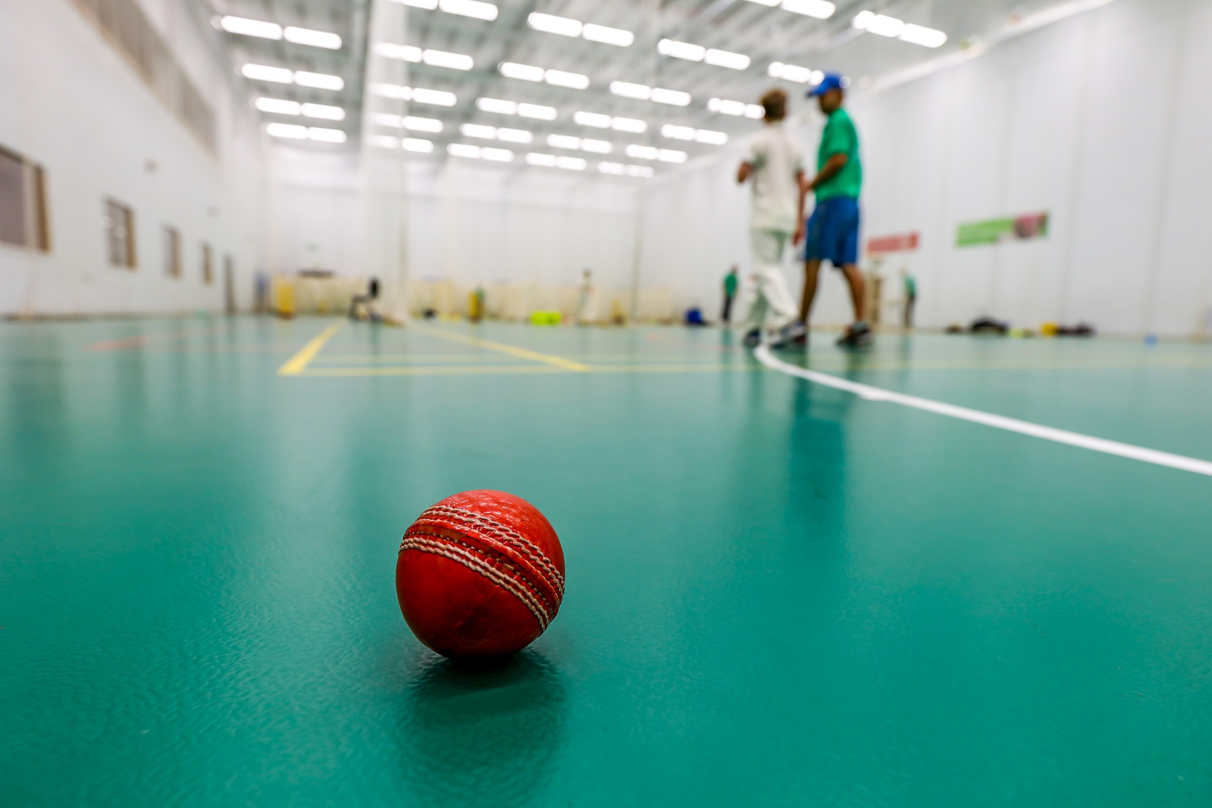 | Indoor training sessions will switch to the fantastic Kent CCC facility until the start of the league season. As before, each session will cost £10 (or £5 for concessions). The venue is The County Ground, Worsley Bridge Road, Beckenham, London, BR3 1DR at the following dates and times (note the change in days):  Monday 1 April 8pm to 9.30pm  Monday 8 April 8pm to 9.30pm  Tuesday 16 April 8pm to 9.30pm  Tuesday 23 April 8pm to 9.30pm  Tuesday 30 April 8pm to 9.30pm  Tuesday 7 May 8pm to 9.30pm
 | Once the weather and surfaces at the ground become dry enough, we will host training at the club ground on Thursday evenings. Please keep an eye out for a start date.
CricketForce 2019 – 6/7 April (and probably 13/14 April)

In 2017, we kicked off CricketForce nationally – see this ECB video - and made some substantial improvements to the facilities. We are running this event again and there are lots of improvements to get through so please volunteer your time, if you can. The following jobs, in particular, require skilled labour so please make yourself known if you have the skills to take these on:

- Fix ceiling panel in bar lounge and paint
- Fix roof above bar lounge to prevent future leaks
- Fix metal loop fastener on main front gate (to affix a padlock)
- Make sure all doors open and close easily – re-aligning locks where necessary
- Make sure all toilets and showers are operational

If you are unable to make 6/7 April, we are running a follow up on 13/14 April.

Senior Membership Fee’s now due!

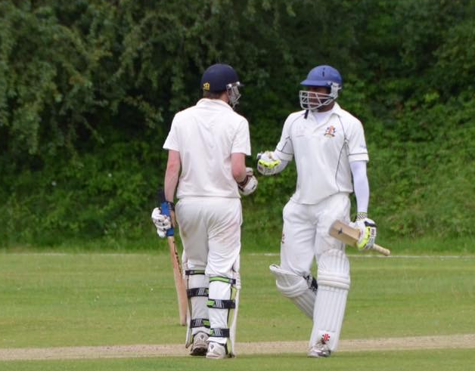 | (Message from Dan Johnson – Senior Membership Secretary)  It’s that time of year again when I start banging the drum about membership payments. So please do start paying your memberships! We are still doing the early bird offer so get in quick and save yourself a few quid! Details of what to pay can be found on the website. Click here for Men’s Cricket and click here for Women’s Cricket.  Please use the reference which includes your name and ‘Subs’.  Streatham & Marlborough Cricket Club  Barclays  s/c: 20-80-57  a/c: 80617997  As per usual folks, if you want to talk to me about paying in instalments or have any questions around the concessions etc, then please do drop me a line on the new club email account enquiries.SMCricketClub@gmail.com or speak to me in person at any of the net sessions or pre-season games.
Pre-Season Cricket in April / Early May

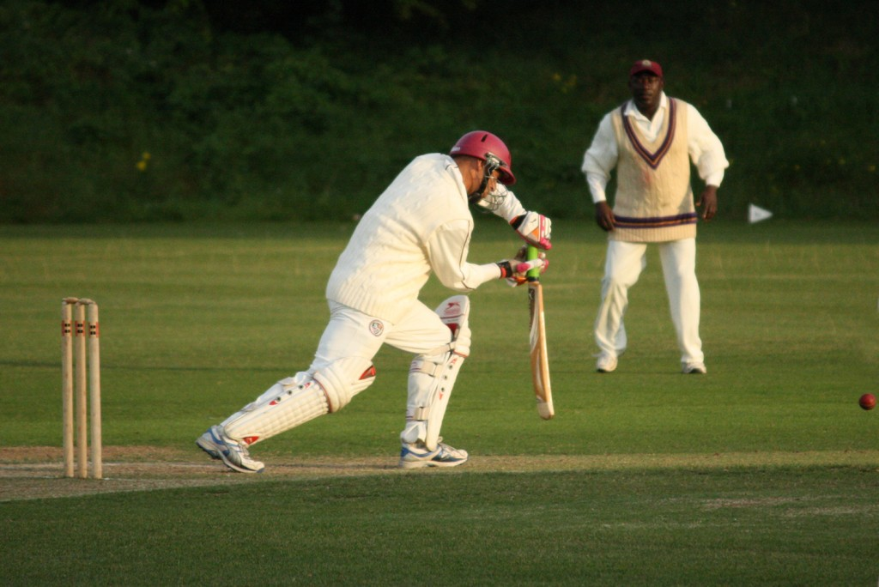 | Conditions allowing, we have the following fixtures scheduled before the League season commences on 11 May.  Date Team Time Opposition (Venue)  13/04 Saturday 1st XI 12:00 Cheam (A)  13/04 Saturday 2nd XI 12:00 Catford & Cyphers (H)  20/04 Saturday 1st / 2nd XI 12:00 Purley (A)  20/04 Saturday 3rd XI 12:00 Kingstonian (H)  20/04 Saturday 4th XI 12:00 Dulwich (H)  21/04 Sunday 1st XI 13:00 Statics (H)  27/04 Saturday 1st XI 12:00 Kingstonian (H)  27/04 Saturday 2nd XI 12:00 Bank of England (A)  27/04 Saturday 3rd XI 12:00 Dulwich (A)  27/04 Saturday 4th XI 12:00 Mitcham (H)  28/04 Women’s 1st XI 13:00 Stoke D’Abernon (A)  28/04 Sunday 1st XI 13:00 Spencer (H)  04/05 Saturday 1st XI 12:00 Chipstead (A)  04/05 Saturday 2nd XI 12:00 Blackheath (H)  04/05 Saturday 3rd / 4th XI 12:00 Intra-Club (H)  05/05 Sunday 1st XI 13:00 Southwark (H)  If anyone wants to know more about how selection works, please see the FAQs on our main website. For league fixtures, please see our Play-Cricket site.

Cricket Coach Wanted for Women’s Section

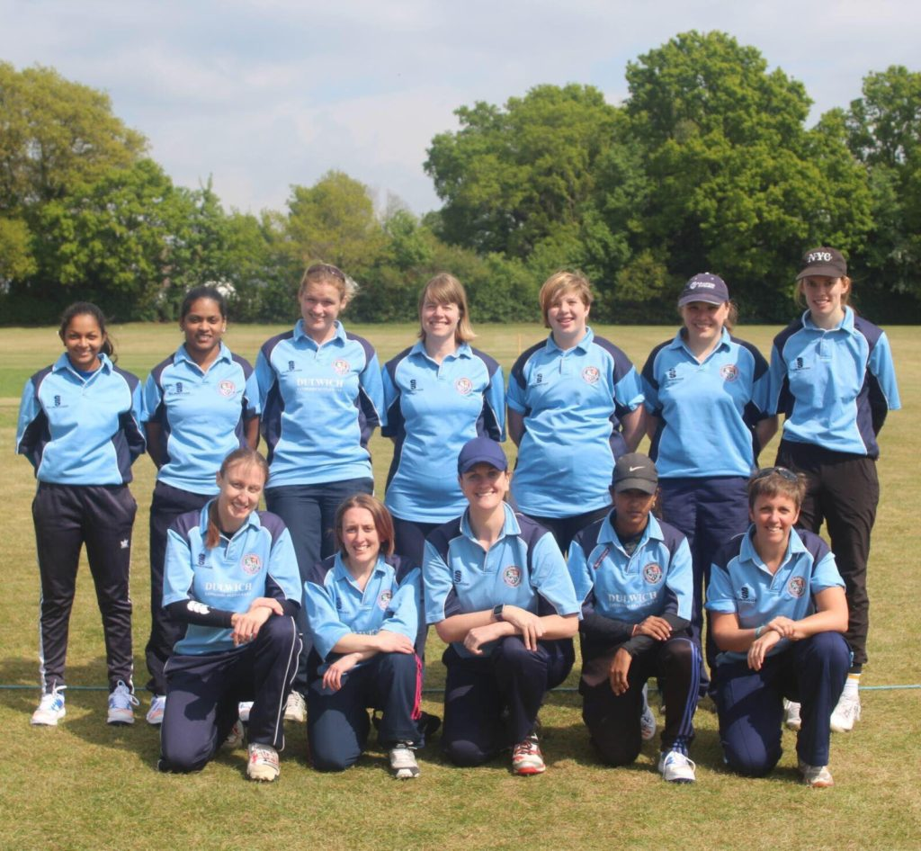 | The women’s section have had some great coaching this winter but the current coach is not available this summer so we’re in the market for a new coach!  The successful applicant would ideally be qualified, available for the majority and able to run structured sessions. This position would be paid and training will be 6.30pm to 8.30pm at the club on Thursday evenings throughout the summer from late April. Contact Kathryn (kathryntharby@gmail.com) or Emma (emmawilliams13@icloud.com) for more information.

In other news:

- Please help the Committee serve the club more effectively by answering this very short survey from the ECB. If you need any further information about club policies, development plans etc, please check the website!

- Senior kit, featuring the logos of Simon Wright Jewellery and Brown Building, can now be purchased from AllRounder Cricket by clicking here. David Brown has generously covered the additional printing cost of his logo – this discount (£3.49) will be applied automatically to “MY BASKET” when you choose an item

- Pavilion Update: we are still discussing designs with our potential nursery partners but our Landlords (Dulwich Estates) appear positive on the project, which is very good news. Timeline remains tight but we’re still pushing for a build starting at the end of the season. More detail on the website.

- Drink local! Along with stocking Gipsy Hill Brewing Company beers, the bar will also be stocking Brockwell IPA from the Canopy Beer Co in Herne Hill. Hurrah!

- Finally, we are now on Instagram! Please follow to keep up to date with news, events and general cricket musings. Links to all our social media can be found on the sign-off below.

As ever, if you have any questions, feel free to get in touch.
Best,
Dan
Men’s Club Captain

Proudly supported by:
Follow us on:
Fundraise via:

