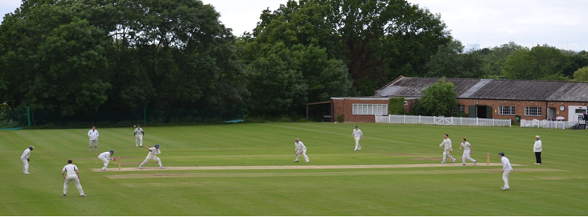

**Streatham & Marlborough Cricket Club**

**Winter Update – 11 January 2019**

Happy New Year! A few updates for you in advance of the first senior men’s training session…

* The **club quiz** make its long awaited return on **15 February** following a two year hiatus. A popular night and we hope you’ll encourage family and friends to come along too.

7pm for 7.30pm start.

Pavilion, Dulwich Common, SE21 7EX.

£10 per entrant (includes a curry from Dulwich Tandoori – they charge by the plate so e-mail me to **confirm attendance**)

Here’s a teaser to pique your interest: Name five countries that begin and end with the same letter - but NOT the letter ‘A’. A tough one…

* It’s time to dust off the kit as the **men’s senior training starts this Sunday**. There are further details below but we’ve again had a number of new enquiries from potential members which is very positive. We hope to see many new faces at training so please make them feel welcome, as per usual.

It is worth noting that the initial turnout at nets is generally pretty high before settling to a more manageable number in subsequent weeks. We’ve not previously had any issues with getting everyone a bat and a bowl but, if demand remains high, we will make provisions for additional nets or a booking system.

We do have to pay for the hall so need to collect £10 for those in full employment and £5 for concessions (i.e. unemployed, student, over 65s and those earning below London Living Wage) per session.

Dates: Every Sunday from 13 January – 24 March

Time: 11am - 1pm

For those that are new to the club, or new to cricket, please scroll down for some specific information on the club training so you know what to expect.

* A very brief round-up of news from the Executive Committee meeting last night: The ground is slowly recovering from hottest summer on record, we are monitoring. Michael Nicholas (new club Treasurer) reports that finances are relatively healthy and we will be offering payment via an app for match fees / membership this year. We would like more sponsors, [packages available](http://streathammarlboroughcc.co.uk/index.php/pavilion-project/). Ladies in need of new recruits so please spread the word. We agreed to enter [Surrey Slam](http://www.surreyslam.com/) (local Wednesday evening T20 competition) for the men’s section. Junior training is going very well with strong numbers forecast for 2019 and the club remain in discussions with potential pavilion partner. Happy to provide more detail by request.

Best,

Dan

Men’s Club Captain

[](http://www.streathammarlboroughcc.co.uk/)

Proudly supported by:

[](http://www.brownbuilding.co.uk/)[cid:image021.png@01D2B90A.9B143510](http://www.mirash.co.uk/)

[cid:image025.png@01D2B90A.9B143510](https://www.facebook.com/groups/SMCricketClub/)[cid:image026.png@01D2B90A.9B143510](https://twitter.com/smcricketclub?lang=en)

**SMCC Open Age Men’s Winter Nets**

The venue is Dulwich College Prep School (42 Alleyn Park, London SE21 7AA). You need to go through two sets of doors at the main entrance and then follow the path to the right which leads to a sports hall. At the entrance to the sports hall, there will be someone to welcome you and sort the cash side of things. Cash only please although it is possible to do a bank transfer if really necessary.

At 11am, we’ll head into the halls and do some form of warm up before pulling the nets out. In the past, the stronger players generally occupy the nets at the far side of the hall but everyone is pretty happy to mix and match. For new guys, it’s probably best to take a quick look to see where you’ll fit in best and then jump in to a lane. I can happily report that the lads across the club are welcoming. If you don’t have any gear, someone in your lane will have kit he’s happy to lend. If you’ve got a ball, great, but no problem if not. There should be a bag of balls or one that can be borrowed. There’s no official coaching at these sessions.

Senior colts (U15 and above) are welcome to attend. Please note that the club makes every effort to maintain good general safekeeping practices but cannot guarantee there will be DBS checked members at every practice.

In terms of what to wear, a white top is preferably but anything which is comfortable will do. Trainers only as we’ll be inside.