**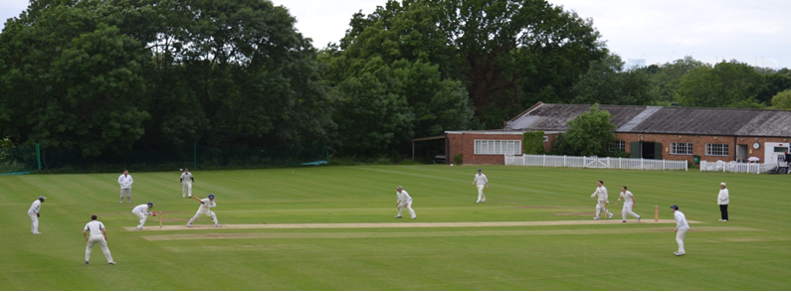**

**Streatham & Marlborough Cricket Club**

**SMS – 8 August 2018**

|  |  |  |  |  |  |  |
| --- | --- | --- | --- | --- | --- | --- |
| [**FIXTURES**](http://stmcc.play-cricket.com/website/web_pages/112572) | [**RESULTS**](http://stmcc.play-cricket.com/website/web_pages/112573) | | [**MEMBERSHIP**](http://www.streathammarlboroughcc.co.uk/index.php/membership/) | [**KIT**](http://www.allroundercricket.com/teamwear/cricket-teamwear/s/streatham-and-marlborough-cc) | | [**PAVILION**](http://streathammarlboroughcc.co.uk/index.php/pavilion-project/) |
|  | |  | | |  | |
| (Click for further information) | | | | | | |

Welcome to the Streatham & Marlborough Sweep (SMS) – the latest information from SMCC

**Overview of last weekend**

Whilst some of us were nursing sore heads having celebrated the Club President’s surprise 70th birthday long into Saturday evening, the story of the weekend was developing from the Sunday 1s. Long term club member, Curtis Knott, scored his maiden century to go along with 66 for the Men’s 4s the day before. A former junior with the club it’s great to see him raise the bat - well done buddy! The Men’s 1s were the only other side to record victory but worth mentioning the following other individual performances: Snowden (72), Rea (66), Steel (52\*), Gibbens (10-3-36-5) & Mahey (8-0-34-4).

There is currently no food arranged for Saturday evening but the 6th XI are next on the roster for the team socials and will be doing a sausage sizzle on the 18th. If anyone wants to volunteer for this weekend, please let me know.

**Social Calendar**

|  |  |  |  |  |  |  |  |  |  |  |  |  |  |
| --- | --- | --- | --- | --- | --- | --- | --- | --- | --- | --- | --- | --- | --- |
| 20160909_192229.jpg | |  |  | | --- | --- | | 18 Aug | Club social hosted by the 6th XI | | 26 Aug | President’s Day | | 1 Sept | Final League Games Party hosted by the 4th XI | | 15 Sept | Junior End of Season Awards | | 20 Oct | Senior End of Season Awards “Dinner & Dance” | | 24 Nov | Annual General Meeting | |

If you have any questions, please let me or another member of the committee know.

Cheers,

Dan

Men’s Club Captain

[](http://www.streathammarlboroughcc.co.uk/)

Proudly supported by:  
[](http://www.brownbuilding.co.uk/)[cid:image021.png@01D2B90A.9B143510](http://www.mirash.co.uk/)

[cid:image025.png@01D2B90A.9B143510](https://www.facebook.com/groups/SMCricketClub/)[cid:image026.png@01D2B90A.9B143510](https://twitter.com/smcricketclub?lang=en)

**Upcoming Fixtures: 9 - 15 August**

|  |  |  |  |  |
| --- | --- | --- | --- | --- |
| **Date** | **Start** | **Team** | **Opposition** | **Venue** |
|  |  |  |  |  |
| Saturday 11 August | 12:00 | 1st XI | Stoke D’Abernon | Away |
|  | 12:00 | 2nd XI | Stoke D’Abernon | Home |
|  | 13:00 | 3rd XI | Normandy | Home |
|  | 13:00 | 4th XI | Normandy | Away |
|  | 13:30 | 5th XI | Bexleyheath | Away |
|  | 13:30 | 6th XI | Gap Week | N/A |
|  |  |  |  |  |
| Sunday 12 August | 14:00 | Ladies Trust XI | Stoke Molesey | Home |
|  | 13:00 | Sunday 1st XI | Southbank | Home |
|  |  |  |  |  |
| Wednesday 15 Aug | 13:00 | Midweek XI | 40 Club | Home |
|  |  |  |  |  |
| League Fixtures can be viewed on our [Play-Cricket site](http://stmcc.play-cricket.com/website/web_pages/112572) | | | | |

**Results: 2 - 8 August**

**1st XI**

Won by 9 wickets

Churt 93ao (34.5) / SMCC 97-1 (16.1)

1st XI League position – [4 / 10](http://surreychampionship.play-cricket.com/website/websites/view_division?id=77475)

**Ladies 1st XI**

Won by concession

Ladies 1st XI League position – [1 / 4](http://womenscsl.play-cricket.com/website/websites/view_division?id=78372)

**Ladies Trust XI**

Gap Week

Ladies Trust XI League position – [3 / 10](http://ssdl.play-cricket.com/website/websites/view_division?id=78015)

**2nd XI**

Lost by 18 runs

Chessington 234ao (48.3) / SMCC 216ao (43.5)

2nd XI League position – [5 / 10](http://surreychampionship.play-cricket.com/website/websites/view_division?id=77481)

*Report:* *Sharif lost the toss and Chessington chose to bat first on a scorching day. SMCC were poor for the first 2 sessions as they made mistakes in the field and regularly bowled boundary balls with the exception of Sarwavkhan who took 2 wickets first up for 13 runs from his 7 overs. At 177-3 it took a brilliant spell from Gibbens to claw it back as he bowled 10 overs on the spin for 5-36.*

*The next three sessions after tea weren’t great either as 3 of the top 4 failed to score. Rea however, made it look easy at the other end as he made 66. Catterall batted nicely with him before departing. Fuller and Williamson looked to get the game in control before they both fell in quick succession. Mayes batted smartly with James but was given out controversially and Chessington wrapped up SMCC’s tail to win by 18 runs.*

*A frustrating day where we just weren’t at the races. Those days happen, but unfortunately for us, we’d left ourselves in a position where we couldn’t afford a day like that. Now it’s on to the last four games, where we look to climb up the table and restore some pride as I know this team deserves to be winning games of cricket and I’ll make sure to do everything I can to get four wins for the boys who’ve fought valiantly for me this season, and in previous years! Let’s end on a high lads! (A Sharif)*

**3rd XI**

Lost by 53 runs

Beddington 182-9 (45) / SMCC 129ao (40.3)

3rd XI League position – [6 / 10](http://surreychampionship.play-cricket.com/website/websites/view_division?id=77486)

**4th XI**

Lost by 80 runs

Reigate Priory 240-8 (45) / SMCC 160ao (34.1)

4th XI League position – [5 / 10](https://surreychampionship.play-cricket.com/website/websites/view_division?id=77491)

**5th XI**

Gap week – friendly played which ended as a winning draw.

5th XI League position – [5 / 8](http://krcl.play-cricket.com/website/websites/view_division?id=77284)

**6th XI**

Lost by 6 wickets

SMCC 212-7 (40) / Beckenham 214-4 (40)

6th XI League position – [5 / 9](http://krcl.play-cricket.com/website/websites/view_division?id=77288)  
**Sunday 1st XI**

Won by 193 runs

SMCC 287-4 (40) / Dulwich Wanderers 94ao (21.5)

**Sunday 2nd XI**

Lost by 8 wickets

SMCC 94ao (26.5) / Old Rutlishians 97-1 (13)