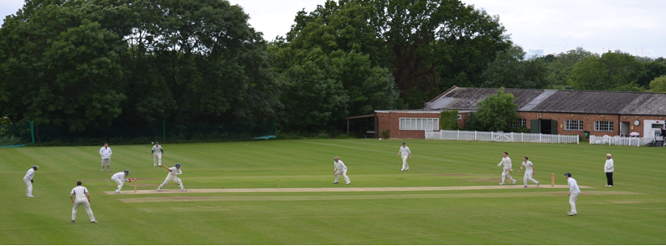
Streatham & Marlborough Cricket Club
May Update

FIXTURES | RESULTS | MEMBERSHIP | KIT
(Click for further information)

Dear all,

Bloody weather…! Of our 16 pre-season fixtures, only two have been completed... and I understand from other clubs we’re one of the lucky ones! This has made selection particularly tricky so it will take some time getting members in the appropriate sides – please bear with us for the first couple of weeks and approach Justin (details below) if you have any issues.

The good news is that the weekend is set fair so hopefully we get a full programme of cricket and you all get a chance to enjoy the new joiner drinks on Saturday evening hosted by our Ladies XI. Event info can be found on the following link with the event centred around a BBQ and cocktails… https://www.facebook.com/events/157730851732765/?ti=icl

As ever, the quickest way to keep informed are via our Facebook Group (not to be confused with our less used Facebook page) for updates and Twitter feeds so please do join/follow.

Membership

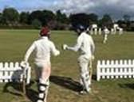 | The early bird offer is now over for returning members so please note when making payments. New members can continue to access ‘early bird’ pricing throughout their first season with the club.  More details can be found here but the club would like to re-iterate that cost will not be a barrier to play and anyone requiring assistance should contact the membership secretary, Dan Johnson (daniel.johnson11@nhs.net).

Selection

In short, our intention is to select a strong, well-balanced side to give a fair and equal opportunity for all XIs to perform. We ask that players play where selected to the best of their ability and uphold the club’s code of conduct when representing the club.

Please send your availability for the upcoming fixtures (specifying Wednesday, Saturday and/or Sunday) to the various captains or our Chair of Cricket (Justin Sbresni - justin@busbyproductions.com / 07951 601 948) before Monday evening on the week of a game. If we haven’t heard by then, we will assume you are unavailable to minimise disruption later in the week.

Men’s and Ladies Summer Training

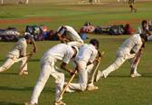 | With the ground firming up, both men’s and ladies senior training will take place on a Thursday evening at the club (Dulwich Common, SE21 7EX) from 18.30 and will continue (weather allowing) until the end of the season. All are welcome.

Match Fees

In addition to the Membership fee, a “match fee” is applied to all players for each game and covers the costs associated with the game (ground prep, tea's, balls, officials and so on). This applies to friendly and league cricket at the rate of £12 per match (or £6 for concessions).

You can obtain a discount by buying in bulk and paying in advance. There is £2 discount on a full rate (i.e. £50 for 5 matches, £100 for 10 matches) and a £1 discount for concessions (£25 for 5 matches, £50 for 10 matches).

Social Calendar

5 May | New Member Drinks hosted by the Ladies XI
19 May | Club social hosted by the 3rd XI
27 May | Karen Goodchild Memorial Game
16 June | “Final Push” Pavilion Fundraising Party
14 July | Club social hosted by the 2nd XI
21 July | Club social hosted by the 5th XI
28 July | Club social hosted by the 1st XI
18 Aug | Club social hosted by the 6th XI
26 Aug | President’s Day
1 Sept | Final League Games Party hosted by the 4th XI
20 Oct | Senior End of Season Awards “Dinner & Dance”
24 Nov | Annual General Meeting

If you have any questions, please let me or another member of the committee know.
Cheers,
Dan
Men’s Club Captain

Proudly supported by:

Upcoming Fixtures: 5 – 11 May

Date | Start | Team | Opposition | Venue
Saturday 5 May | 12:00 | 1st XI | Old Wimbledonians | Home
 | 12:00 | 2nd XI | Leatherhead | Away
 | 13:00 | 3rd XI | Malden Wanderers | Away
 | 13:00 | 4th XI | Wimbledon | Home
 | 13:30 | 5th XI | TBC | Away
 | 13:30 | 6th XI | Bexleyheath | Home
Sunday 6 May | 13:00 | Ladies 1st XI | Canterbury | Home
 | 13:00 | Sunday 1st XI | Southwark | Home
Monday 7 May | 14:00 | T20 XI | Cheam (cup) | Home
League Fixtures can be viewed on our Play-Cricket site

