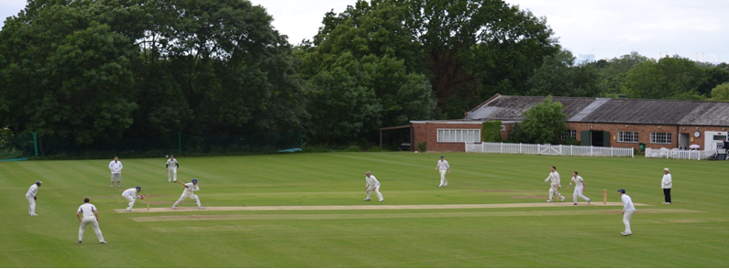

**Streatham & Marlborough Cricket Club**

**April Pre-Season Update – 11.04.2018**

Dear all,

Firstly, a huge thank you to all who volunteered their time last weekend to help with the [CricketForce](https://www.ecb.co.uk/be-involved/club-support/club-events/natwest-cricketforce) efforts. It is hugely appreciated and some good progress was made.

Given the games for this weekend have been cancelled (just awaiting a confirm for the away fixture), we will be hosting a further two days of CricketForce. We had a disappointingly low turnout over the weekend and finished early due to poor weather. This left a number of tasks outstanding. **Please do make every effort to give a couple of hours – many hands make light work**!

Much of the remaining work is based outdoors and we will need clear weather to proceed. If it’s raining, do not travel. Please check with our [Facebook Group](https://www.facebook.com/groups/SMCricketClub/) (not to be confused with our less used Facebook page) for updates or contact the following people – Dan Ellis (leading on Saturday only – 07949 230 664) or Karen Klomp (leading on Sunday only - 07920 742 973).

**CricketForce 2018 - Saturday 14 April & Sunday 15 April - 11am – 4pm**

|  |  |
| --- | --- |
| cid:image003.jpg@01D3CFF2.834B1ED0 | NatWest CricketForce is a nationwide initiative aimed at cricket clubs to ensure grounds and facilities are ready for the new season.  This year, we plan to make the ground as welcoming as possible. This benefits both you, the member, and makes us a much more viable proposition as a hireable facility - a key source of revenue!  Please report to Karen or myself or see the list on the noticeboard in the bar upon arrival to see what needs doing. |

**Charity Cycles**

|  |  |
| --- | --- |
| cid:image002.jpg@01D3D1A2.B3A4DE70  cid:image004.jpg@01D3D1A2.B3A4DE70 | Two of our members are taking part in charity bike rides to raise funds for two very worthwhile causes.  Curtis Knott will be riding for Cancer Research whilst Benn Glazier riding for the Mental Health Foundation.  If you wish to support their efforts, please do so on the following links.  <https://www.justgiving.com/fundraising/curtis-knott1>  <https://uk.virginmoneygiving.com/BennGlazier> |

**Last Man Stands Cricket**

|  |  |
| --- | --- |
| [cid:image005.jpg@01D3D1A2.B3A4DE70](https://www.lastmanstands.com/) | One of our new members, Andy Spry, captains a Last Man Standing side and is looking to recruit a couple of new players into his squad. All the games are on a Thursday night at Regent’s Park and start at 18.30. He is ideally looking for an opening bowler and a keeper. It’s a decent standard, good lads and a chance to grab a beer after the game – if you fit the bill please contact Andy direct on 07720 498 349.  For more details on LMS cricket generally – please click [here](https://www.lastmanstands.com/) |

If you have any questions, please let me know. Otherwise, I hope to see you at the weekend!

Cheers,

Dan

Men’s Club Captain

[](http://www.streathammarlboroughcc.co.uk/)

Proudly supported by:  
[](http://www.brownbuilding.co.uk/)[cid:image021.png@01D2B90A.9B143510](http://www.mirash.co.uk/)

[cid:image025.png@01D2B90A.9B143510](https://www.facebook.com/groups/SMCricketClub/)[cid:image026.png@01D2B90A.9B143510](https://twitter.com/smcricketclub?lang=en)