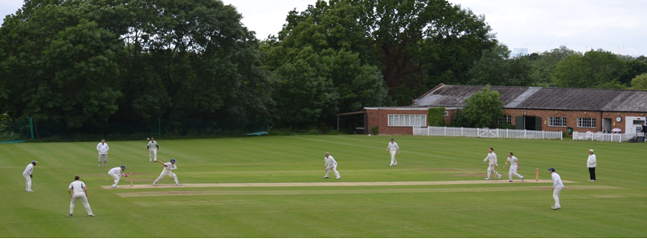

**Streatham & Marlborough Cricket Club**

**April Pre-Season Update – 10.04.2018**

Dear all,

Unfortunately rain has meant more cancellations to the scheduled and there’ll be **no games this coming weekend**. Apologies for this but I’m hearing it’s a common issue – this was Worcestershire CCC at the end of last week…!

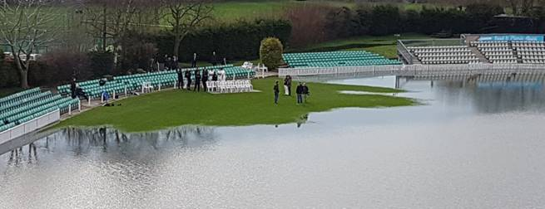

Also, a big **thank you** to those of you who donated their time to CricketForce over the weekend. It was hugely appreciated and there has been some good progress. We were, however, a bit light on personnel and had to cut the event short with poor weather on Sunday.

**Men’s Pre-Season Nets**

|  |  |
| --- | --- |
| cid:image013.jpg@01D2B90A.9B143510 | We’ve managed to secure a venue to host three more indoor net sessions - the Kent CCC Indoor School on [Worsley Bridge Road, Beckenham BR3 1DR](https://www.bing.com/local?lid=YN1029x16777192762535416925&id=YN1029x16777192762535416925&q=The+County+Ground&name=The+County+Ground&cp=51.4200630187988%7e-0.0279747191816568&ppois=51.4200630187988_-0.0279747191816568_The+County+Ground&FORM=SNAPST).  This session runs as follows:  Tuesday 17/04               8.30pm – 10.00pm  Tuesday 24/04               8.30pm – 10.00pm  Tuesday 01/05               8.30pm – 10.00pm  As before, there’s no need to book so please feel free to attend as you like. We do, however, have to pay for the hall so need to collect a small amount of cash from those who attend. It’s £10 for those in full employment and £5 for concessions (i.e. unemployed, student, over 65s and those earning below London Living Wage) per session. |

As ever, if you have any questions, please let me or another member of the committee know.

Cheers,

Dan

Men’s Club Captain

[](http://www.streathammarlboroughcc.co.uk/)

Proudly supported by:  
[](http://www.brownbuilding.co.uk/)[cid:image021.png@01D2B90A.9B143510](http://www.mirash.co.uk/)

[cid:image025.png@01D2B90A.9B143510](https://www.facebook.com/groups/SMCricketClub/)[cid:image026.png@01D2B90A.9B143510](https://twitter.com/smcricketclub?lang=en)